February 10, 2024
CALIFORNIA RICE TESTING RESULTS
Pursuant to the Rice Certification Act of 2000 (California Food and Agricultural Code Sections 55000 et seq.) (“Act”) provides a mechanism by which it will be known when any rice determined to possess characteristics of commercial impact is planted for commercial production. Based on this body of law and the notifications required under it the California Rice Commission has determined that there is no transgenic rice in commercial production in California at this time.
The Act requires that all rice grown in California be submitted to an advisory board for a determination of characteristics of commercial impact. (FAC Section 55051) No transgenic rice has been submitted to the advisory board for this determination.
There is also a requirement that the advisory board be notified regarding rice being grown for research purposes. (FAC Section 55052) This provision also requires the submission of a protocol for advisory board approval to ensure the research will not result in commercial impact to other rice. The advisory board has received notifications and submittals regarding research on transgenic rice.
The Act provides for mandatory testing of seed and the crop produced from that seed. Extensive testing of 2023 basic and foundation seed and the 2023 crop produced from that seed utilizing the USDA approved 35S-BAR test at the .01% detection level have resulted in non-detects.
Based on the foregoing, the California Rice Commission is confident that there is no transgenic rice in commercial production in California. It is further confident that the transgenic rice being grown for research is being grown on a very small scale and handled in such a manner to minimize the potential of impact on other rice.
California Rice Commission
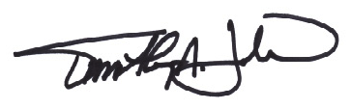
Tim Johnson
President & CEO

